Counters and Registers
Counters and registers belong to the category of MSI sequential logic circuits. They have similar architecture, as both counters and registers comprise a cascaded arrangement of more than one flip-flop with or without combinational logic devices. Both constitute very important building blocks of sequential logic and different types of counter and register available in integrated circuit (IC) form are used in a wide range of digital systems. While counters are mainly used in counting applications, where they either measure the time interval between two unknown time instants or measure the frequency of a given signal, registers are primarily used for the temporary storage of data present at the output of a digital circuit before they are fed to another digital circuit. We are all familiar with the role of different types of register used inside a microprocessor, and also their use in microprocessor-based applications. Because of the very nature of operation of registers, they form the basis of a very important class of counters called shift counters. In this chapter, we will discuss different types of counter and register as regards their operational basics, design methodology and application-relevant aspects. Design aspects have been adequately illustrated with the help of a large number of solved examples. A comprehensive functional index of a large number of integrated circuit counters and registers is given towards the end of the chapter.
Ripple (Asynchronous) Counter
A ripple counter is a cascaded arrangement of flip-flops where the output of one flip-flop drives the clock input of the following flip-flop. The number of flip-flops in the cascaded arrangement depends upon the number of different logic states that it goes through before it repeats the sequence, a parameter known as the modulus of the counter.
In a ripple counter, also called an asynchronous counter or a serial counter, the clock input is applied only to the first flip-flop, also called the input flip-flop, in the cascaded arrangement. The clock input to any subsequent flip-flop comes from the output of its immediately preceding flip-flop. For instance, the output of the first flip-flop acts as the clock input to the second flip-flop, the output of the second flip-flop feeds the clock input of the third flip-flop and so on. In general, in an arrangement of n flip-flops, the clock input to the n^{th} flip-flop comes from the output of the (n−1) ^{th} flip-flop for n>1.
The figure below shows the generalized block schematic arrangement of an n-bit binary ripple counter.
As a natural consequence of this, not all flip-flops change state at the same time. The second flip-flop can change state only after the output of the first flip-flop has changed its state. That is, the second flip-flop would change state a certain time delay after the occurrence of the input clock pulse owing to the fact that it gets its own clock input from the output of the first flip-flop and not from the input clock. This time delay here equals the sum of propagation delays of two flip-flops, the first and the second flip-flops. In general, the nth flip-flop will change state only after a delay equal to n times the propagation delay of one flip-flop. The term ‘ripple counter’ comes from the mode in which the clock information ripples through the counter. It is also called an ‘asynchronous counter’ as different flip-flops comprising the counter do not change state in synchronization with the input clock. The propagation delay of each flip-flop, of course, will depend upon the logic family to which it belongs.

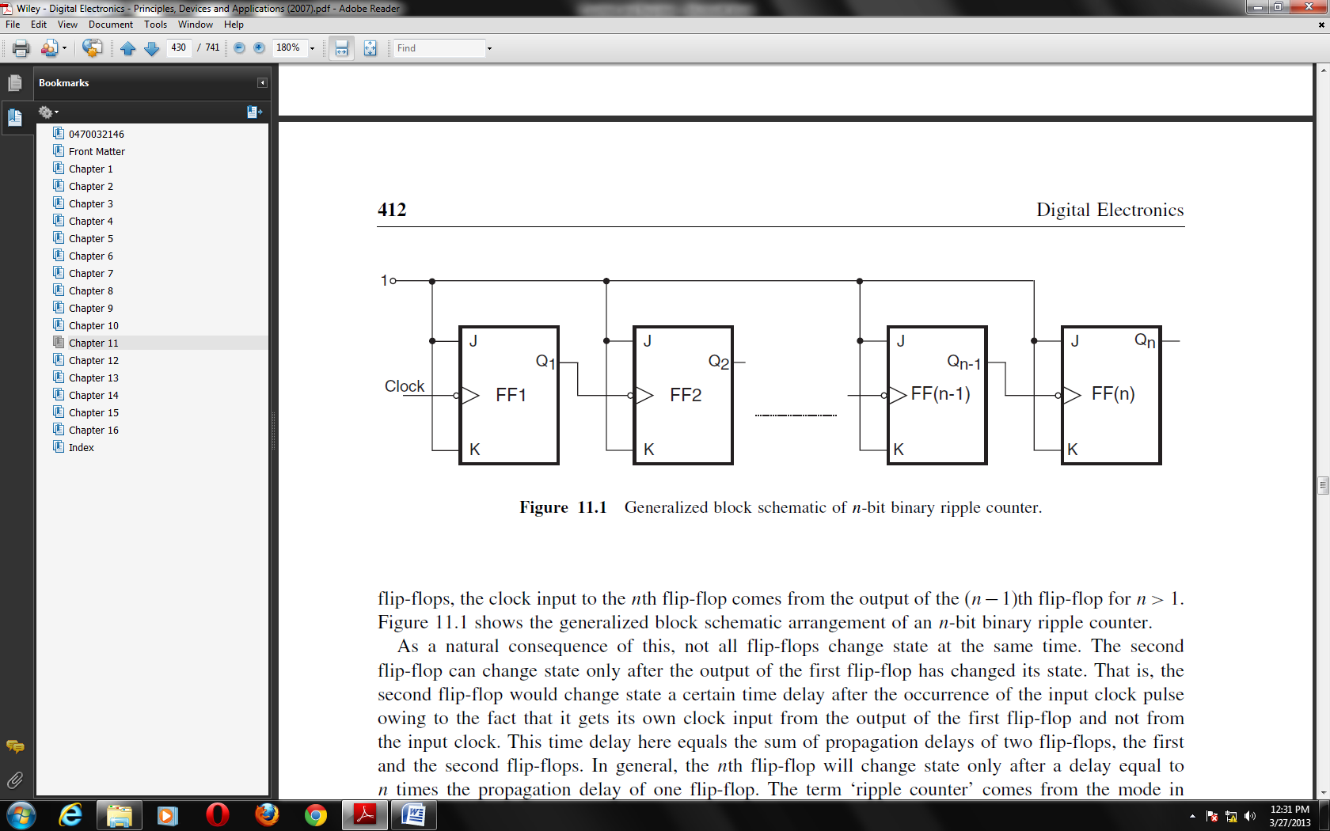
Propagation Delay in Ripple Counters
A major problem with ripple counters arises from the propagation delay of the flip-flops constituting the counter. The effective propagation delay in a ripple counter is equal to the sum of propagation delays due to different flip-flops. The situation becomes worse with increase in the number of flip-flops used to construct the counter, which is the case in larger bit counters. An increased propagation delay puts a limit on the Maximum frequency used as clock input to the counter. We can appreciate that the clock signal time period must be equal to or greater than the total propagation delay. The maximum clock frequency therefore corresponds to a time period that equals the total propagation delay.
Synchronous Counter
In a synchronous counter, also known as a parallel counter, all the flip-flops in the counter change state at the same time in synchronism with the input clock signal. The clock signal in this case is simultaneously applied to the clock inputs of all the flip-flops. The delay involved in this case is equal to the propagation delay of one flip-flop only, irrespective of the number of flip-flops used to construct the counter. In other words, the delay is independent of the size of the counter.
Modulus of a Counter
The modulus (MOD number) of a counter is the number of different logic states it goes through before it comes back to the initial state to repeat the count sequence. An n-bit counter that counts through all its natural states and does not skip any of the states has a modulus of 2^{n}. We can see that such counters have a modulus that is an integral power of 2, that is, 2, 4, 8, 16 and so on. These can be modified with the help of additional combinational logic to get a modulus of less than 2^{n}.
To determine the number of flip-flops required to build a counter having a given modulus, identify the smallest integer m that is either equal to or greater than the desired modulus and is also equal to an integral power of 2. For instance, if the desired modulus is 10, which is the case in a decade counter, the smallest integer greater than or equal to 10 and which is also an integral power of 2 is 16. The number of flip-flops in this case would be 4, as 16 = 2⁴. On the same lines, the number of flip-flops required to construct counters with MOD numbers of 3, 6, 14, 28 and 63 would be 2, 3, 4, 5 and 6 respectively. In general, the arrangement of a minimum number of N flip-flops can be used to
construct any counter with a modulus given by the equation
_2N −1 + 1_ ≤ modulus ≤ 2N (11.1)
Binary Ripple Counter – Operational Basics
The operation of a binary ripple counter can be best explained with the help of a typical counter of this type. The figure below shows a four-bit ripple counter implemented with negative edge-triggered J-K flip-flops wired as toggle flip-flops. The output of the first flip-flop feeds the clock input of the second, and the output of the second flip-flop feeds the clock input of the third, the output of which in turn feeds the clock input of the fourth flip-flop. The outputs of the four flip-flops are designated as Q0 (LSB flip-flop), Q1, Q2 and Q3 (MSB flip-flop. The waveforms appearing at
Q0, Q1, Q2 and Q3 outputs as the clock signal goes through successive cycles of trigger pulses is also shown. The counter functions as follows.
Let us assume that all the flip-flops are initially cleared to the ‘0’ state. On HIGH-to-LOW transition of the first clock pulse, Q0 goes from ‘0’ to ‘1’ owing to the toggling action. As the flip-flops used are negative edge-triggered ones, the ‘0’ to ‘1’ transition of Q0 does not trigger flip-flop FF1. FF1, along with FF2 and FF3, remains in its ‘0’ state. So, on the occurrence of the first negative-going clock transition, Q0 to ‘1’. The Q2 and Q3 outputs remain unaffected. Therefore, immediately after the occurrence of the second HIGH-to-LOW transition of the clock signal, Q0 = 0, Q1 = 1, Q2 = 0 and Q3 = 0. On similar lines, we can explain the logic status of Q0, Q1, Q2 and Q3 outputs immediately after subsequent clock transitions. The logic status of outputs for the first 16 relevant (HIGH-to-LOW in the present case) clock signal transitions is summarized in Table below.
Thus, we see that the counter goes through 16 distinct states from 0000 to 1111 and then, on the occurrence of the desired transition of the sixteenth clock pulse, it resets to the original state of 0000 from where it had started. In general, if we had N flip-flops, we could count up to 2^{N} pulses before the counter resets to the initial state. We can also see from the Q0, Q1, Q2 and Q3 waveforms, as shown that the frequencies of the Q0, Q1, Q2 and Q3 waveforms are f/2,f/4, f/8 and f/16 respectively. Here, f is the frequency of the clock input. This implies that a counter of this type can be used as a divide-by-2^{N} circuit, where N is the number of flip-flops in the counter chain. It may be noted that frequency division is one of the major applications of counters.

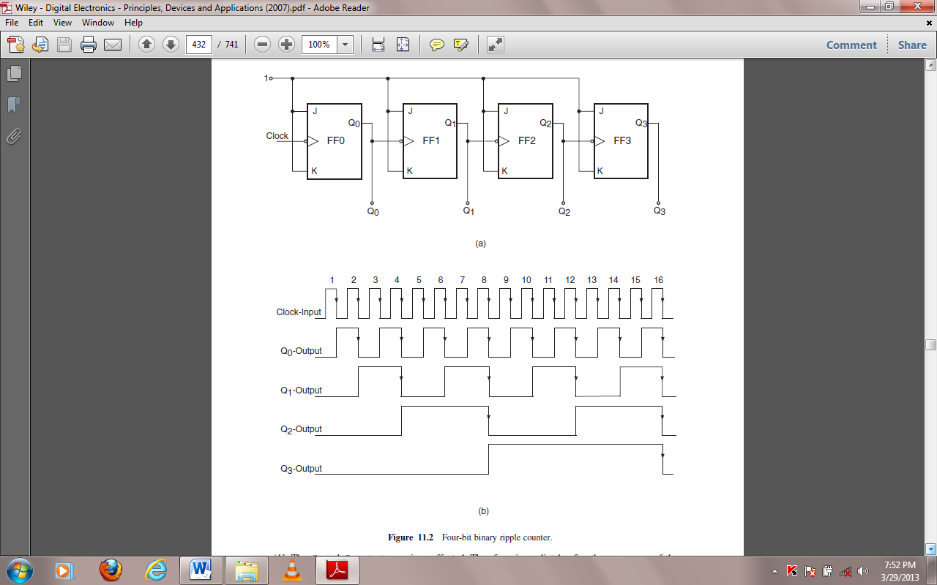
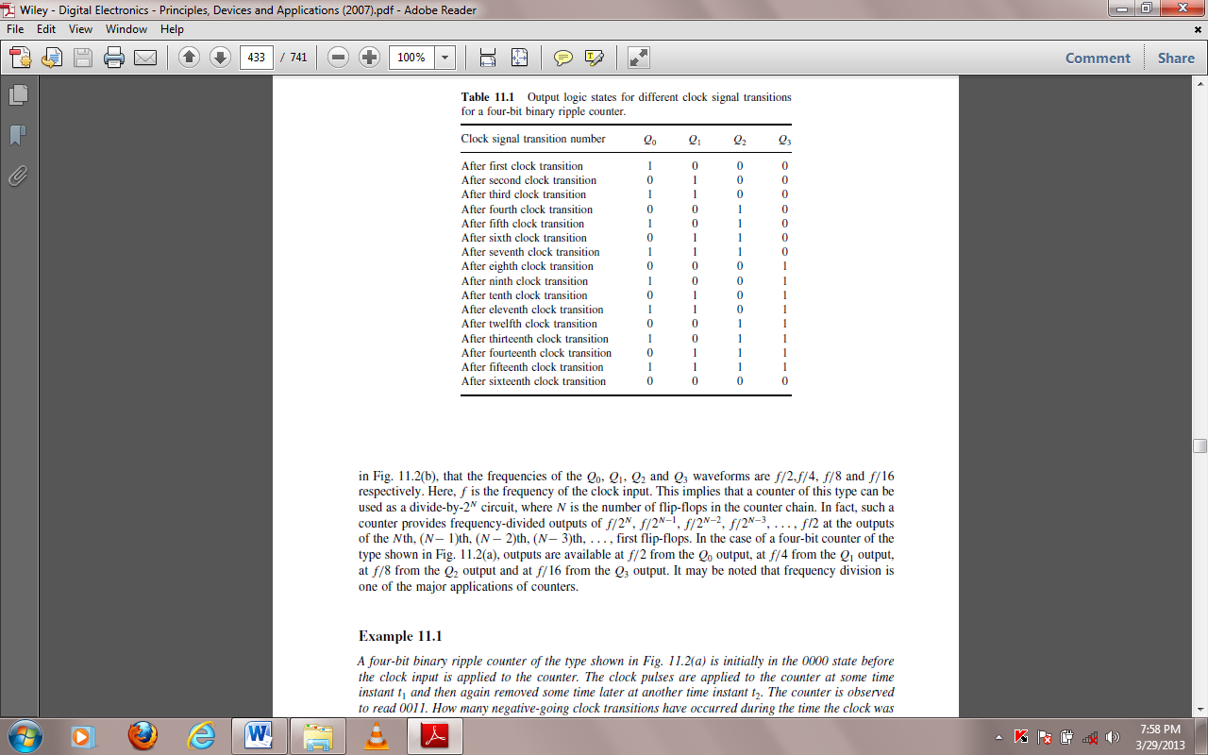
Binary Ripple Counters with a Modulus of Less than 2^{N}
An N-flip-flop binary ripple counter can be modified, as we will see in the following paragraphs, to have any other modulus less than 2^{N} with the help of simple externally connected combinational logic.
Consider the four-flip-flop binary ripple counter arrangement shown below. It uses J-K flip-flops with an active LOW asynchronous CLEAR input. The NAND gate in the figure has its output connected to the CLEAR inputs of all four flip-flops. The inputs to this three-input NAND gate are from the Q outputs of flip-flops FF0, FF1 and FF2. If we disregard the NAND gate for some time, this counter will go through its natural binary sequence from 0000 to 1111. But that is not to happen in the present arrangement. The counter does start counting from 0000 towards its final count of 1111. The counter keeps counting as long as the asynchronous CLEAR inputs of the different flip-flops are inactive. That is, the NAND gate output is HIGH. This is the case until the counter reaches 0110. With the seventh clock pulse it tends to go to 0111, which makes all NAND gate inputs HIGH, forcing its output to LOW. This HIGH-to-LOW transition at the NAND gate output clears all flip-flop outputs to the logic ‘0’ state, thus disallowing the counter to settle at 0111. From the eighth clock pulse onwards, the counter repeats the sequence. The counter thus always counts from 0000 to 0110 and resets back to 0000. The remaining nine states, which include 0111, 1000, 1001, 1010, 1011, 1100, 1101, 1110 and 1111, are skipped, with the result that we get an MOD-7 counter.
The timing waveforms for this counter are shown. By suitably choosing NAND inputs, one can get a counter with any MOD number less than 16. Examination of timing waveforms also reveals that the frequency of the Q² output is one-seventh of the input clock frequency.
The waveform at the Q² output is, however, not symmetrical as it would be if the counter were to go through its full binary sequence. The Q3 output stays in the logic LOW state. It is expected to be so because an MOD-7 counter needs a minimum of three flip-flops. That is why the fourth flip-flop, which was supposed to toggle on the HIGH-to-LOW transition of the eighth clock pulse, and on every successive eighth pulse thereafter, never gets to that stage. The counter is cleared on the seventh clock pulse and every successive seventh clock pulse thereafter.
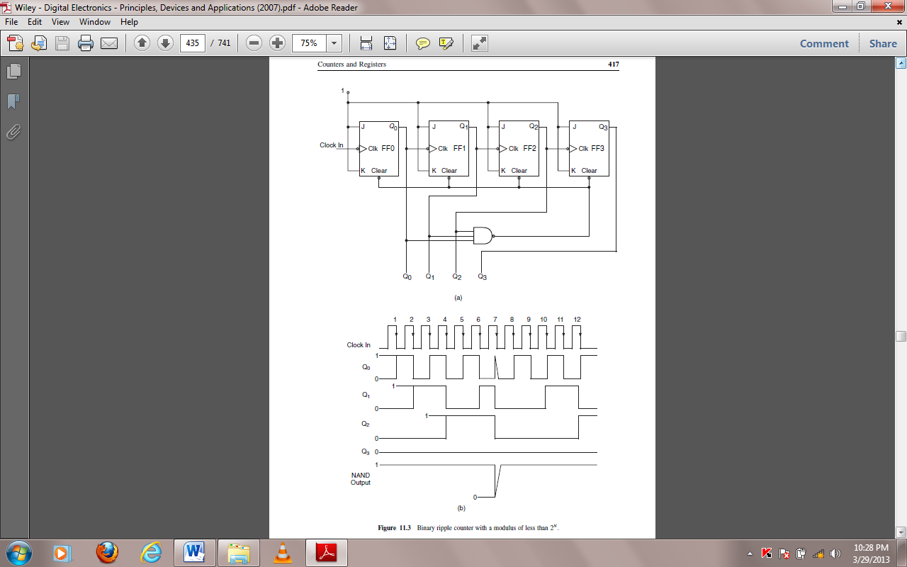



Binary ripple counter with a modulus of less than 2^{N}.

